Banff & Buchan
Food Growing and Green Spaces Initiative Funding
2024/2025

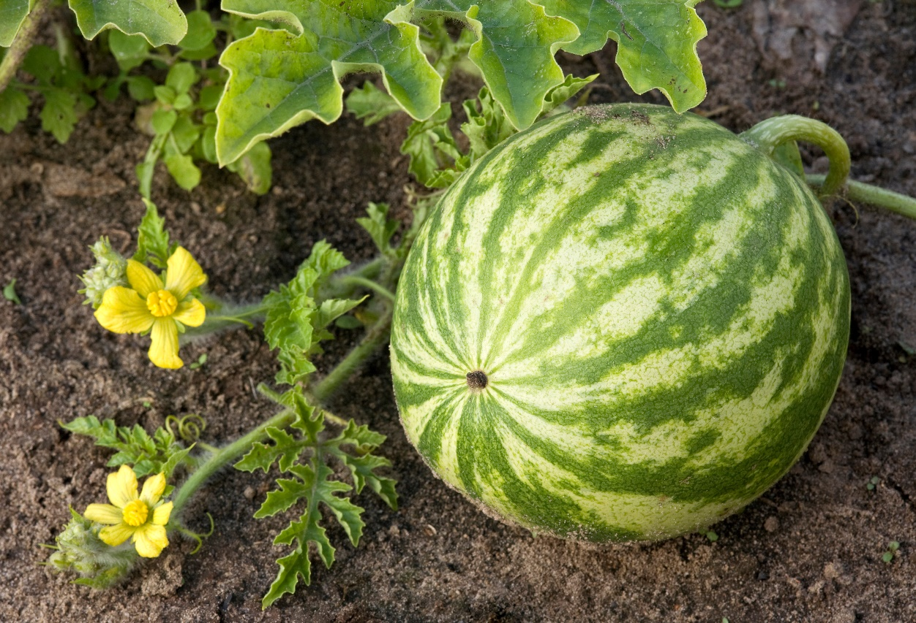

The aim of the Banff and Buchan Area Food Growing and Green Spaces Initiative Fund is to enable Aberdeenshire Council’s Banff and Buchan Area Committee Budget to be used specifically to respond to and support community projects in the creation of food growing spaces and related initiatives to address the needs of communities and encourage an active interest and development of growing spaces, supporting a “Field to Fork” approach and enhancing our natural environment.

This might include the creation or improvement of existing food growing spaces at properties such as sheltered housing and schools, allowing people access to fresh air, exercise, and social interaction, acknowledging benefits to their health and wellbeing. It is also open to community groups or organisations who may wish to provide a growing space within their community.

Please review the attached guidance note and criteria before completing the application form below.

Application Form

1. Contact details - please provide details below:

Name of group/organisation:
Contact name:
Position:
Address (including postcode):
Telephone number(s):
Email address:
Name of Treasurer:
Telephone number:
Email address:
Group/organisation’s bank details: | Name of Bank:  Sort Code:  Account No.:

2. Description of project - please provide a description of your proposed project including aims, objectives, and outcomes:

Description:

3. Project Plan - please provide details of the plan for your project:

Project Plan
Name of person responsible for the project.
Contact details if different from contact at section 1
When will the project start?
What are the key milestones in the project?

What are the key risks in the project?

4. Maintenance arrangements - please confirm that your project will not require any future maintenance by Aberdeenshire Council in terms of either a financial or time costs. Please identify who will be responsible for any future maintenance and stewardship:

5. Project Cost - please provide details of the expected cost of your project:

Total cost of this phase of the project:
Amount requested (including VAT where appropriate):
Breakdown of cost:

Please provide details of your current bank balance. If any of the balance has been ring-fenced for other projects, please provide detailed information. All information received may be considered in the decision-making process:

Current bank balance (where appropriate):
Ring-fenced money (please provide detailed information on any of the money that has been ringfenced for other projects and therefore cannot be used towards this project):

The person signing this form will be responsible for ensuring that the money awarded is used for the purpose stated in the original application and that receipts are sent to the Area Manager’s office no later than 14 March 2025.

Name:
Position:
Date:

Please ensure you provide the following:

The application form
Copy of quotation for proposed works or goods
A Constitution, or Memorandum and Articles
Copy Insurance Certificate
A copy of the most recent independently examined accounts
3 most recent bank statements
Where appropriate, a copy of your Food Growing & Green Spaces Agreement

Please email your application form and supporting documents to: banffandbuchanamo@aberdeenshire.gov.uk

If you have any questions, please telephone: 01467 530700.

Once the project is underway, successful applicants will be requested to provide a short update, along with photographs. This will capture the progress of the work so that the Area Committee may have an indication of how the money has been spent for the benefit of the community.

(Please see Privacy Notice)

