**Formartine Area Committee**

**Ward 7 – Ocean Winds Community Fund**

**Grant Application**

**Please complete this form with details of your proposed project, enclosing any detailed costing figures for the project and as much supporting financial information as is available.**

**The criteria for applications is detailed at the end of this form.**

**Your completed form and accompanying information should be returned by email to** [formartineareaoffice@aberdeenshire.gov.uk](mailto:formartineareaoffice@aberdeenshire.gov.uk)

|  |
| --- |
| Name of Group Applying: |
|  |
| Address: |
|  |
| Phone Number: |
|  |
| Email Address: |
|  |
| Date of Submission: |
|  |
| Description of Project: |
|  |
| Please give a short summary of **who** will benefit from your project and **how**? |
|  |
| If other partners are involved, please detail which partners are involved and their contribution. |
|  |
| Please detail how your project fits with the Council Plan Priorities. (See Criteria 1 for further information). |
|  |
| Please detail the total project cost and cost breakdown. |
|  |
| How much are you applying for? (Criteria 11 and 12 detail the limits). | |
|  | |
| Please include any **other sources of funding** and the amount contributed.  **What can the community / group contribute**?  Please specify any “**in-kind**” contributions such as labour or skills. (Criteria 18 provides further detail). | |
|  | |
| Has this project previously received funding from this fund? | |
|  | |
| **In order for your application to be considered, you must submit as much detailed financial information as is available and, where applicable, a project plan. (Please see Criteria 11 and 12 for further information).** | |
| **\*\* Please include any other supporting information on a separate sheet** ** | |

**Criteria for Applications to the Ward 7 - Ocean Winds Community Fund**

1. All Proposals must be in line with and address the Council’s Strategic Pillars which are:

* **A Sustainable Economy** – We will support a strong and diverse economy by attracting people of working age to our region, complementing our highly skilled local workforce.
* **Connected Communities** – We will work with communities and partners to enhance the sense of connection among our places. This includes supporting communities to come up with innovative solutions to ensure our places are resilient and vibrant.
* **Living Well Locally** – We will encourage and support our residents to lead healthy and active lives and contribute meaningfully to their communities. We will make proactive choices that will allow us to cater to the needs of our increasingly ageing population.

Further information can be found here:

[Aberdeenshire Council Plan 2024 – 2029 - Aberdeenshire Council](https://www.aberdeenshire.gov.uk/council-and-democracy/council-plan/)

1. Applications must be for projects which are contained within the geographical boundary of Ward 7.

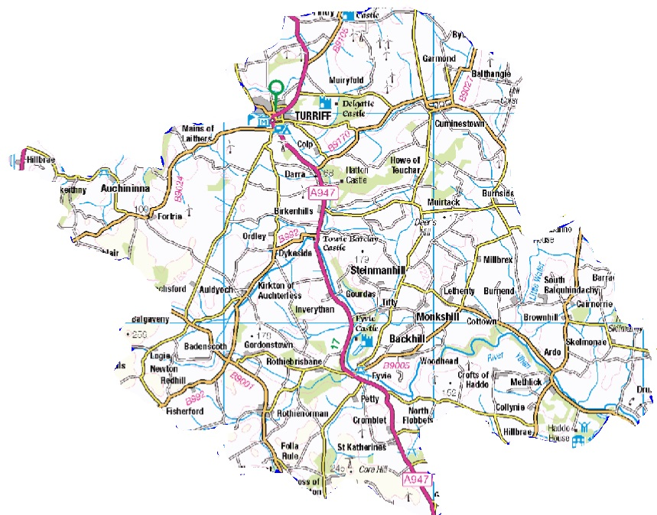

1. Payment will be made retrospectively on receipt of invoices and confirmation that the money has been spent in accordance with the proposals applied for. Payment will be made by BACS transfer to a group’s bank account. Groups will be added to the BACS system, if not already included, on the award of any grant funding.
2. Grants should be claimed within **6-months of award, unless otherwise agreed.** The current funding round will be open for 3 years from January 2025.
3. Successful applicants will be required to provide a short report on the project and the impact of the funding **when submitting their claim**, unless the need for a later deadline has been demonstrated by the applicant and agreed by the Area Office.
4. All applications must demonstrate legacy, in terms of a long-lasting positive impact on their community. Grants for projects which have a legacy of less than one year will not be considered.
5. All applications must demonstrate that other funding sources have been explored.
6. Applications for supporting core Council services, such as supporting pupils to undertake mainstream school qualifications, will not be supported.
7. Applications for supporting trips abroad will not be supported.
8. The Committee will not ordinarily look favourably on applications for repeat funding for the same project.
9. Applications will be available for **100% of overall project costs** up to a maximum of **£5,000** per grant. All applications **must** include as much detailed financial information as is available and, where applicable, a project plan. Examples of appropriate financial information include audited accounts (if available), up to date bank statements, and ledger accounts.
10. In exceptional circumstances, groups can apply for up to **£20,000 up to 75% of project costs** but in addition to the information required at section 11, these applications will require additional financial scrutiny, (such an independently verified accounts) and evidence of match-funding, ahead of being considered by Formartine Area Committee.
11. Applications will be welcomed for Village or Town Centre Improvements, from both Community Groups and the Formartine Area Manager, for projects for the benefit of the area.
12. Applications will be welcomed from the Formartine Community Planning Group towards Community Action Plans.
13. Applications will be welcomed which help to deliver the priority of PLACE within our settlements. The Place Strategy and associated place and wellbeing outcomes are detailed [here](https://publications.aberdeenshire.gov.uk/acblobstorage/a1b6347c-c59b-492c-9236-d75246a4c0b1/place-strategy.pdf).
14. Applications will be welcomed for projects which demonstrate a commitment to carbon reduction.
15. In-kind contributions may make up to 25% of a projects overall cost. In some cases, calculating the value of in-kind contributions can be relatively simple, for example if it is the contribution of a piece of equipment. Other costs could be a little more difficult, for example, the value of volunteer time. Below is a table that indicates the standard rates, which should be used to calculate volunteer time:

|  |  |  |
| --- | --- | --- |
| **Type of voluntary/in-kind contribution** | **Per Hour** | **Per Day** |
| General, unskilled labour (for example, supervised scrub clearance, ditch-digging, planting, basic administrative support) | £12.21 | £97.68 |
| Specialist, skilled, trained labour (for example, operations for which certificated training is a requirement, such as operating dangerous equipment, driving off-road vehicles, using chemicals) | £18.75 | £150.00 |
| Specialist services, (for example, supervising, training labour teams, surveys, counts, trapping, ringing, diving, printing, designing, photography) | £31.25 | £250.00 |
| Professional services (for example, consultants, lawyers, planners, engineers, accountants, auditors) | £50.00 | £350.00 |

1. Eligibility is limited to properly constituted groups. Applications which are solely, or substantially, for individual benefit will not be considered.
2. The use of the budget cannot commit the Council to recurring expenditure beyond a maximum of three years to tie in with the budget planning cycle.
3. The Privacy Notice accompanying the application form should be retained by the applicant for information purposes.
4. If any further assistance or guidance is required, please contact the Formartine Area Office at [formartineareaoffice@aberdeenshire.gov.uk](mailto:formartineareaoffice@aberdeenshire.gov.uk)

**Privacy Notice**

The Data Controller of the information being collected is Aberdeenshire Council.

The Data Protection Officer can be contacted at the Town House, 34 Low Street, Banff, AB45 1AY.

Email: [dataprotection@aberdeenshire.gov.uk](mailto:dataprotection@aberdeenshire.gov.uk)

Your information is being collected to use for the following purposes:

* **To process your application to the Ward 7 – Ocean Winds Community Fund**
* **To process an AP06 Form* to allow Aberdeenshire Council to make payments to you, if and when they become due, should your application be successful.**

**\*An AP06 Form is a form used to obtain personal details to allow us to make payment e.g. name, address, and bank details**

|  |  |  |
| --- | --- | --- |
| Your information is: |  |  |
| Being collected by Aberdeenshire Council | ✓ |

The Legal Basis for collecting the information is:

|  |  |  |  |
| --- | --- | --- | --- |
| **Personal Data** | | **Special categories of personal data** | |
| Consent |  | The data subject has given explicit ***consent*** to the processing |  |
| Performance of a Contract | ✓ | Processing is necessary for the purposes of carrying out the obligations of the controller or of the data subject in the field of ***employment, and social security and social protection law*** |  |
| Legal Obligations |  |  |  |
| Vital Interests |  | Processing is necessary to protect the ***vital interests*** of the data subject or of another natural person where the data subject is physically or legally incapable of giving consent |  |

|  |  |  |  |
| --- | --- | --- | --- |
| Task carried out in the Public Interest |  | Processing relates to personal data which are made ***public*** by the data subject |  |
| Legitimate Interests |  | Processing is necessary for the establishment, exercise or defence of legal claims or whenever courts are acting in their judicial capacity |  |
| Processing is necessary for reasons of ***substantial public interest*** |  |
| Processing is necessary for the purposes of preventive or occupational medicine, for the assessment of the working capacity of the employee, medical diagnosis, the provision of ***health or social care*** or treatment, or the management of health or social care systems |  |
| Processing is necessary for reasons of public interest in the area of ***public health*** |  |
| Processing is necessary for archiving purposes in the ***public interest***, scientific or historical research purposes or statistical purposes |  |

Where the Legal Basis for processing is either Performance of a Contract or Legal Obligation, please note the following consequences of failure to provide the information:

If the information required is not provided the application will not be progressed to the next stage and where applicable payment(s) will not be made.

Your information will be shared with the following recipients or categories of recipient:

* Formartine Area Committee members to consider the application.
* Formartine Area Office colleagues, and other Council officers as appropriate, to process the application and communicate the outcome.
* Finance colleagues to process relevant forms and payment(s) as required.
* HM Revenue and Customs.
* National Fraud Initiative.
* Spikes Cavell.

Your information will be transferred to or stored in the following countries and the following safeguards are in place:

N/A

The retention period for the data is:

7 years.

The following automated decision-making, including profiling, will be undertaken:

N/A

Please note that you have the following rights:

* to withdraw consent at any time, where the Legal Basis specified above is Consent;
* to lodge a complaint with the Information Commissioner’s Office (after raising the issue with the Data Protection Officer first);
* to request access to your personal data;
* to object, where the legal basis specified above is:

1. Performance of a Public Task; or
2. Legitimate Interests.

* to data portability, where the legal basis specified above is:

1. Consent; or
2. Performance of a Contract;

* to request rectification or erasure of your personal data, as so far as the legislation permits.